

Extremely valuable sessions. The Mentor was outstanding. Lectures are to the point without drag-on. Many thanks for the quality and efforts of INAYAT !

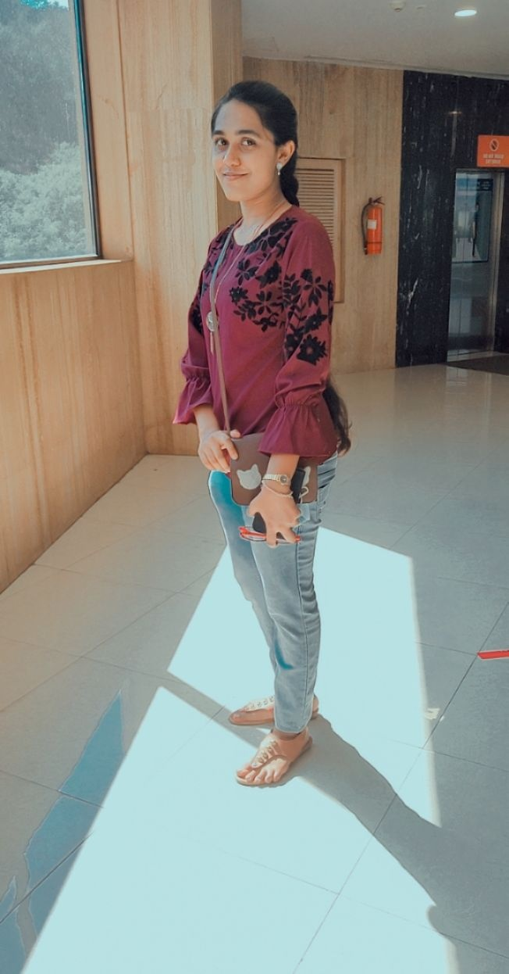

Sincere thanks for the session today. It was highly knowledgeable and offered valuable tips. The mentor did a wonderful job and i found the talk to be very informative and worthwhile. Thanks INAYAT for another inspiring session.

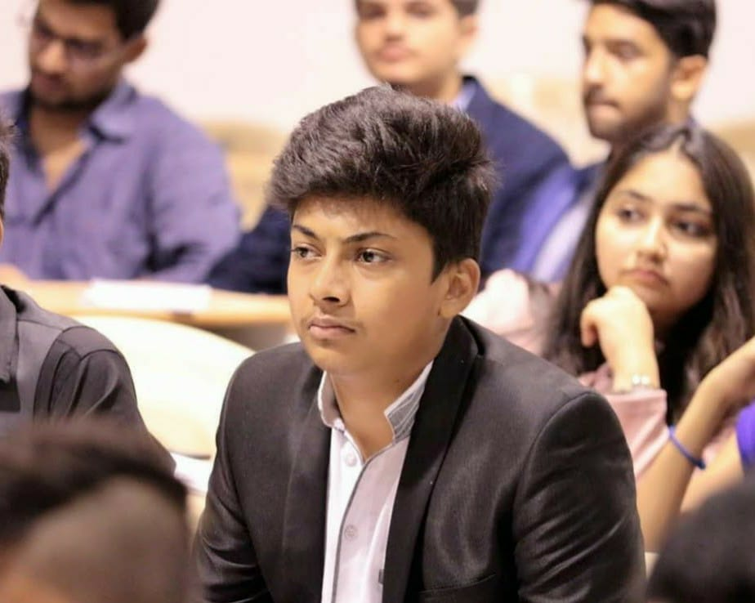

I have always been interested in learning new programming languages. Python was something that I wanted to understand and study for a long time to better my skills. The python classes that I have attended were informative and well-organized. I learned about new processes in coding and language. Overall, it was a great learning experience for me. Many thanks to INAYAT for Quality classes.



The session was wonderful , the way you facilitated It was nice, the example given by you were excellent.